Integration Profile
<Title>

Version 01.00
Technologieplattform Smart Grids Austria Fachhochschule Technikum Wien OFFIS e.V AICO EDV-Beratung GmbH Sprecher Automation GmbH Tiani Spirit GmbH

Document Information
Title
Editor
Authors
Description
Last Changes
sClassification | RED – Sensible Information, Access only for:  YELLOW – Restricted, Access only for:  GREEN – for project-internal usage  WHITE – public

Version History
Version | Date | Changes from | Comment

Acknowledgements
This paper is a result of the IES project funded by the Austrian Climate and Energy Fund, administrated by the Austrian Research Promotion Agency (FFG) under contract number 853693. It has been prepared in the course of work-packages two, three and four to outline the big picture and to identify the different interoperability issues of smart energy systems. The editors would like to thank all the contributing team members of the IES project for their invaluable contribution of knowledge, experience and support toward a better joint understanding of the complexities involved in safe and smart energy systems.
Disclaimer
The content of this document is merely informative and does not represent any formal statement from individuals and/or the Austrian Research Promotion Agency (FFG), the Austrian Climate and Energy Fund, or any official bodies involved. Instead, it is a public document from contributing editors with visionary perspective based on years of experience with interoperability testing and energy system safety. The opinions, if any, expressed in this document do not necessarily represent those of the entire IES project team and/or its funding bodies. Any views expressed are those of the contributing person at the time being and do not commit a common position. This document is distributed under the Creative Commons License Attribution 4.0 International (CC BY 4.0).

Table of Content
1 About the Document 4
2 Definitions 6
3 Integration Profile: <title> 7
3.1 Integration Profile <title> 7
3.1.1 Actors & Transactions 7
3.1.2 Actor Options 9
3.1.3 Information Flow Process 9
3.1.4 Communication Requirements 10
3.1.5 Security Considerations 10
4 Transactions 11
4.1 Transaction: <title> 11
4.1.1 Scope 11
4.1.2 Actor Roles 11
4.1.3 Referenced Standards 11
4.1.4 Interaction Diagrams 12
4.1.5 Security Considerations 13
5 Abbreviations 14
6 References 15

About the Document

An Integration Profile represents a particular technical specification that is integrated into a predefined document structure, a Technical Framework, as specified by IES (Integrating the Energy System). The Technical Framework consists of introductory information on the application scenario it is intended for (Volume 1) and all the Integration Profiles and Functional Integration Profiles that specify the application scenario covered (Volume 2), as shown in Figure 1. The Integration Profile, i.e., the specification of the application scenario, comprises a complete section in the second Volume of the Technical Framework. It may refer to Functional Integration Profiles by bundling them in, and may be bundled into other Integration Profiles, as sketched in Figure 2.
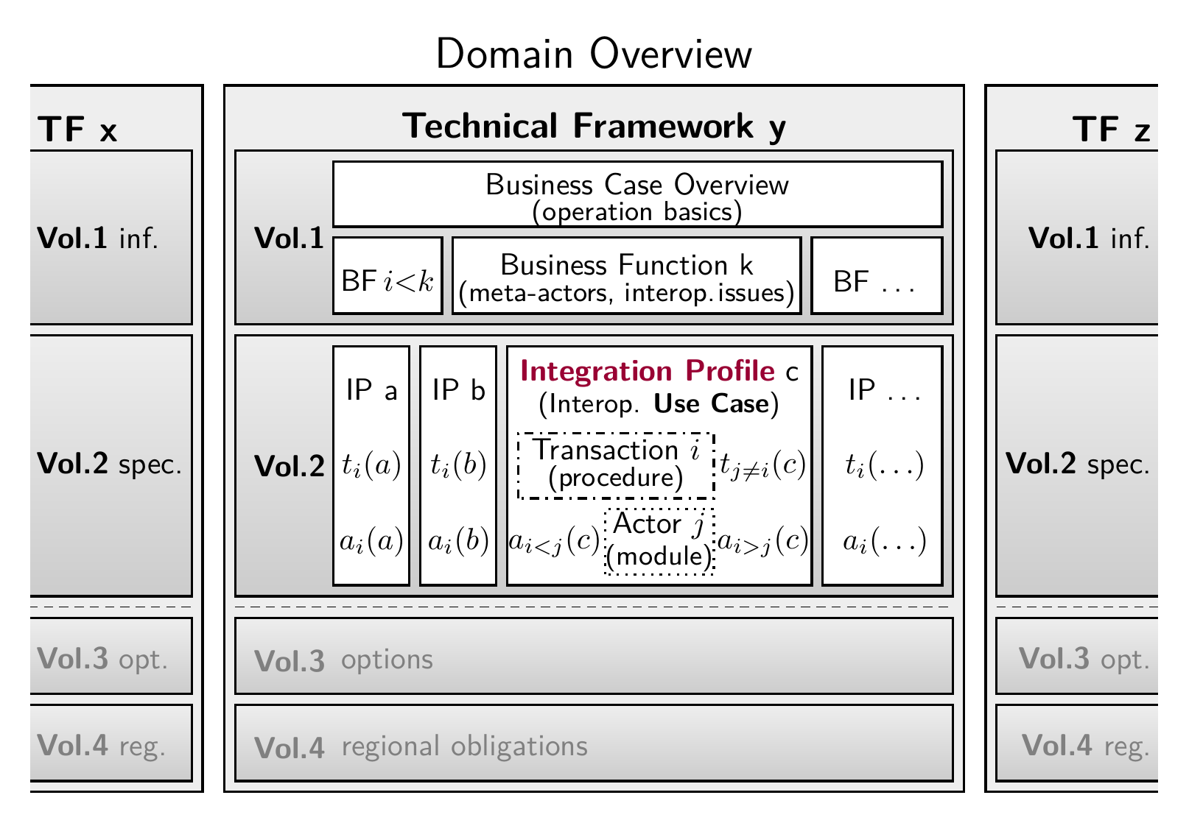
Figure 1: Structure of the IES Technical Framework – with focus on Integration Profiles

Please note that neither a Technical Framework, nor an Integration Profile or its sibling the Functional Integration Profile equal a new standard. This hierarchy of documents rather describes the normalised use and combined application of existing standards and good practices. It is intended to prevent interoperability issues when functionalities and features are implemented as specified by the individual parts constituting a Technical Framework. The individual parts may be reused in other Technical Frameworks to maximise synergies (multiple utilisation of same implementations).

Integration Profiles state constraints and recommendations that specify how to apply standards and good practice to realise a specific part of a Business Function, a specific functionality required to execute a task, in an interoperable manner. Integration Profiles shall specify a single functionality each. The specification shall be unique, meaning that no alternatives or variations shall be specified. The intention is to assure interoperability, which prohibits any uncertainties on how to execute a functionality. This does not have to include the actual implementation, only the steps and the features used shall be specified. Commonly, a variety of standards and good practices need to be combined to achieve the required functionality completely, including side-requirements alike timing, security, and monitoring, in addition to the basic execution requirements. In case the market demands task execution variants, multiple independent Integration Profiles shall be provided, each with a name (identifier) that clearly specifies the variant of the individual Integration Profile.

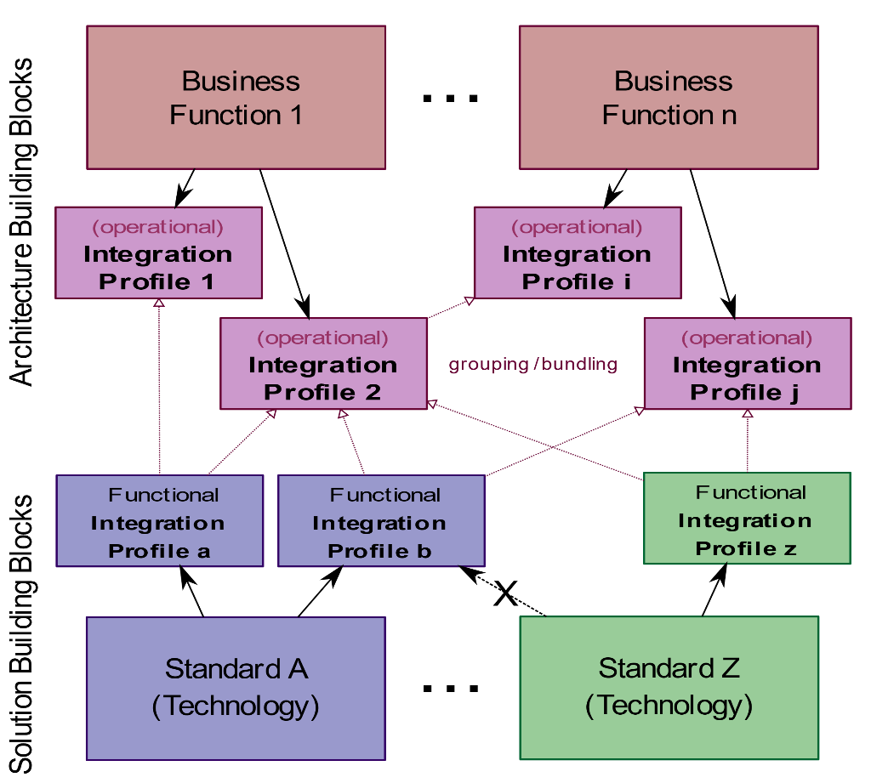
Figure 2: Introducing Operational and Functional Integration Profiles

Integration Profiles commonly refer to Functional Integration Profiles, meaning that they are bundled/grouped with these to specify some standard conforming features. Repeated specification of the same features is avoided, keeping the implementation consistent and the same across Integration Profiles from the same Technical Framework. However, Functional Integration Profiles may offer variants for the Operational Integration Profiles. Thus, to get a unique specification for executing a task, the Integration Profile shall specify the precise variant to be implemented for the functionality covered.

The structure of the Integration Profile specification document is as follows:

Section 1: About the Document
- The introduction stated above (embed as sub-document in every Functional Integration Profile)
Section 2: Definitions
- Specification of terms used throughout the Technical Framework (embedded hereafter)
Section 3: Integration Profile Specification
- Normative specification on how to realise the covered functionality with introducing actors involved
Section 4: Transactions
- Procedures and protocols used to coordinate the actions of actors

Definitions
Actor
is a functional software component of a system that executes transactions with other actors as defined in an Integration Profile.

Business Case
is the economic viable application of an idea or technology.

Business Function
is a feature required to be realised for a Business Case to work.

Conformance Testing
is a standalone process to ensure that the implementation conforms to specified standards and profiles, i.e. the implementations outputs and response are checked against rules and patterns.

Integration Profile
is the specification required to realise a part of a Business Function (or combination thereof) in an interoperable fashion (normalised).

Interoperability Testing
is a process to check whether the system interacts effectively with foreign systems, i.e. when different vendors meet to test their interfaces against each other (e.g. Connectathon).

Interoperability Use Case
is a part of a Business Function that relies on data exchange between different actors according to an Integration Profile (i.e. where interoperability is required).

Meta-Actor
joins functional components (actors) in order to fulfil all the functionalities required for a Business Function (IHE grouping). For the Use Case description, it could be a human operator, but typically it is a software component embedded in some device that provides an interface to some communication infrastructure.

Transaction
is the specification of a set of messages (1..n) exchanged between a pair of actors that realise the Use Case specific information exchange (in one or both directions, in a strict or loose order) as specified by an Integration Profile.

Operational Use Case
is a part of a Business Function that describes an activity not involving any data exchange between actors. This kind of use cases are mentioned in the IES Technical Framework, but not considered in Integration Profiles because per se they do not raise interoperability problems.

Integration Profile: <title>
In this document, an Integration Profile is defined and exemplary implementation options are provided (aka Solution Building Blocks). Integration Profiles are normative descriptions of the features and specifics that need to be implemented in order to realise the respective Business Functions in an interoperable manner. Commonly, where convenient, the name of the Integration Profile shall somehow reflect the name of the Business Function for ease of association.
The following table specifies the mandatory actor grouping for the Integration Profiles defined in this document. Where possible, already defined and approved Integration Profiles from IHE are referenced. The IHE Integration Profiles can be found at http://www.ihe.net. For instance, the integration profile “IHE – Consistent Time” is mentioned.
Table 1: Dependencies among Integration Profiles (bundling with external IPs)
Integration Profile | Depends on | Dependency Type | Purpose
<integration profile title> | IHE - Consistent Time | Each SPS Actor shall be grouped with the IHE Time Client Actor | To ensure consistency among timestamps

Integration Profile <title>
Each integration profile is described in an own section with a unique title.

Actors & Transactions
First, actors and transactions are shown in an Actors-Transactions Diagram, where dependencies between meta-actors and actors and the link to the transactions are visible. Second, all actors and transactions are listed in Table 2 with an optionality for the integration profile and a link to a brief explanation.
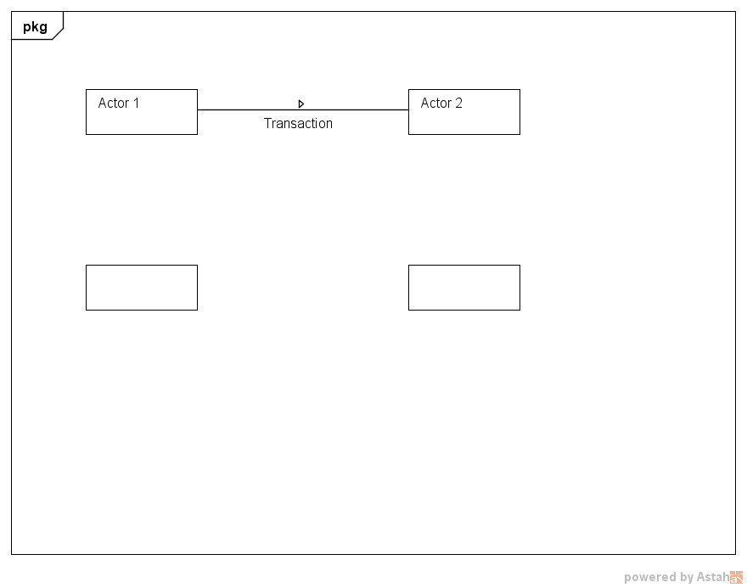
Figure 2: Actors-Transactions Diagram for <title Integration Profile>

Table 2: Transactions for Send Asset Configurations
Actors | Transaction | Optionality | Section

Actor Descriptions and Actor Profile Requirements
All actors involved (see Table 2) in the integration profile are described and profile requirements are mentioned. A reference to Section 3 of Volume 1 is possible.

Transactions
A list of all mentioned transactions in the Actors-Transactions Diagram with a brief explanation is given. The explanation shall contain actors involved, communication protocols needed and a summary of transaction steps.

Actor Options
Options and roles that may be selected for each meta-actor in this profile are listed in Table 3. The options like Station Controller, Plant Operator, Market participant etc. are described and dependencies between options are specified. The role specifies single actors of a meta-actor that are used in the transactions.
Table 3: Actor Options for <integration profile title>
Meta-Actor | Role | Option | Vol. & Section

Information Flow Process
The transmission of data from client to server or the other way round is mostly achieved by a sequence of transaction steps. The detailed process flow and specification of steps, i.e., the transferred data objects and common data classes used per step, can be found in Section 4.

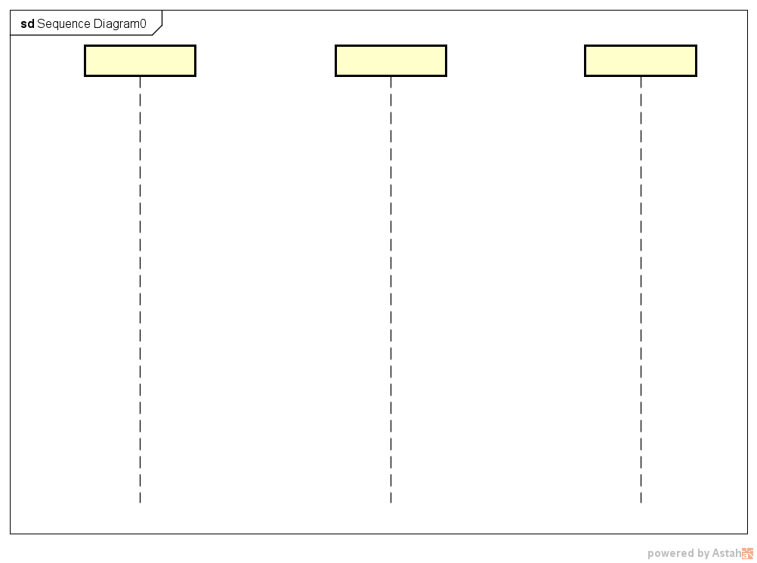
Figure 3: Sequence Diagram for the Information Flow

Communication Requirements
At this section general communication requirements for the integration profile are mentioned like the message type and transmission delay.

Security Considerations
At this section general security aspects for the integration profile are mentioned like the actor authentication and logging of messages.

Transactions
Transactions describe a concrete implementation of the interoperability issue described in the Business Function in Volume 1 of the Technical Framework which were specified through the Integration Profiles in Section 3. The interoperability issues are described in each transaction as brief interoperability use cases which demonstrate the challenge and actors involved of the transaction. Therefore, a UML sequence diagram is used to show single steps and the schema for the data exchange. Additionally, used standards and security considerations are mentioned.

Transaction: <title>
For each transaction, a subsection with a unique title is created.

Scope
The transaction description starts with a scope in which the interaction between two or more actors is textually described. Additionally, hints and exceptions can be mentioned.

Actor Roles
The actors involved in the transaction are listed in Table 4 with a brief description of the kind of interaction with the actors as well as the link to the meta-actor.
Table 4: Actor Roles for <transaction title>
Actor | Description | Meta-actor

Referenced Standards
Standards which are used in the transaction are listed here. Optional, a short description of the standard can be included.

Interaction Diagrams
The interactions of the transaction are shown by a UML sequence diagram. It can include all aspects of the sequence diagram defined by the OMG to describe the data flow between actors. Based on the sequence diagram, single steps of the transaction are described by further subsections.

Figure 4: Sequence Diagram for the Interactions

<title> e.g. Create Message or Transmit Message

Each step of the transaction is described by a new subsection by triggering events, message semantics and expected actions.

Trigger Events
Some conditions can be assigned to a triggering event which has happen before the message option is executed.

Message Semantics
The concrete message semantic is described and depicted. For instance, the scd file for the message exchange is demonstrated.

Expected Actions
Here the results and the behaviour of the actors after receiving the data are described.

Security Considerations
In this section, further mostly technical or legal requirements for the transaction are mentioned.

Abbreviations
Each abbreviation used in the technical framework are explained in this section.
IEC | International Electrotechnical Commission
IES | Integrating the Energy System
IHE | Integrating the Healthcare Enterprise
OMG | Open Management Group
SCD | Substation Configuration Description
UML | Unified Modelling Language

References
All references used in the Technical Framework are mentioned here.

The profile Consistent Time (CT) is defined in the latest IHE’s IT Infrastructure (ITI) Technical Framework Vol.1 and Vol.2

